**Lab 7**

**Sqoop:**

//SQL codes:

create table stocks (id int not null primary key, symbol varchar(20), quote_date Date, open_price float, high_price float, low_price float);

describe stocks;

insert into stocks (id, symbol, open_price) values (1, "FB", 240.00), (2, "GG", 240.24), (3, "MS", 242.40);

select * from stocks;

quit;

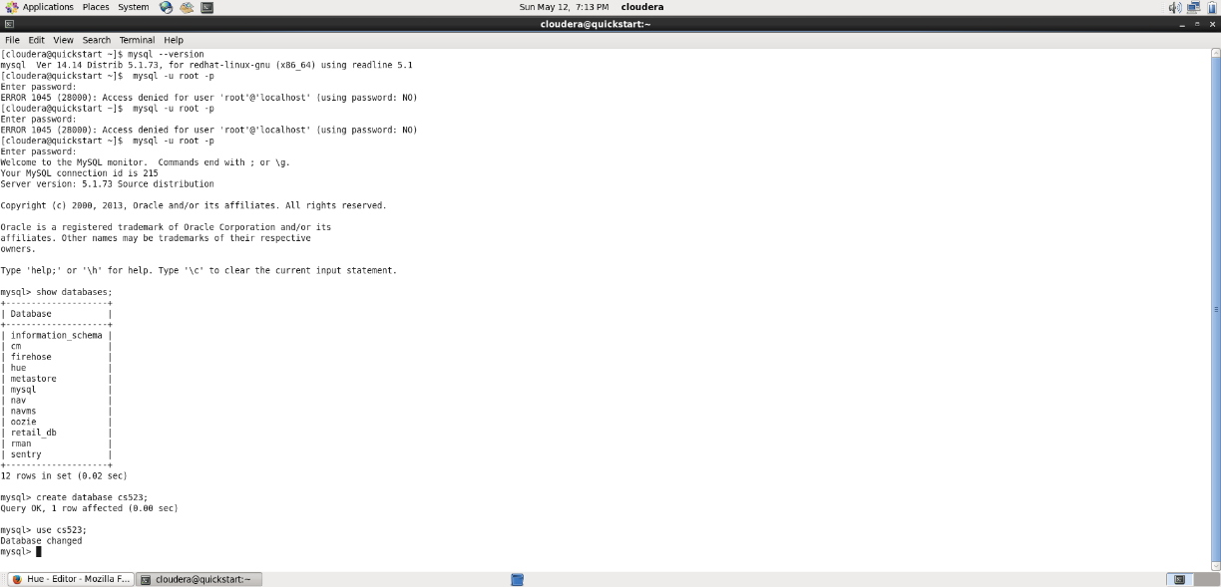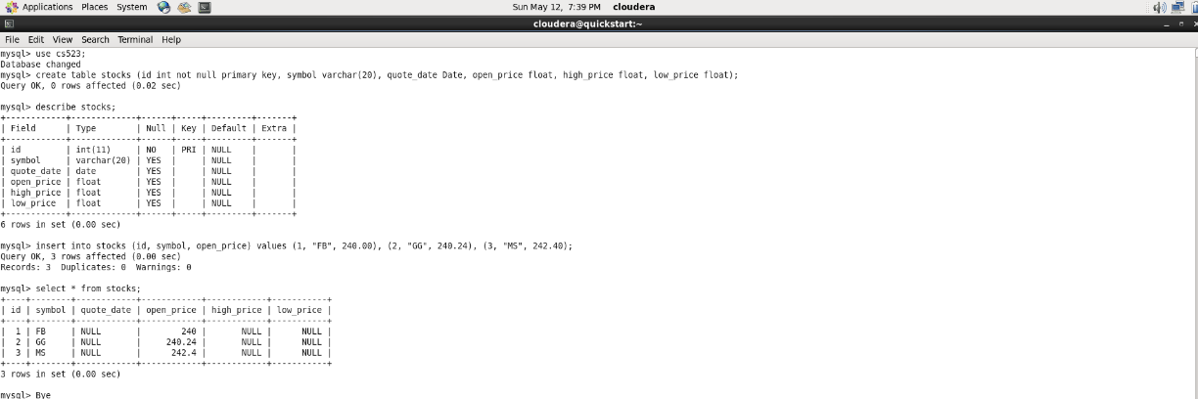

//Sqoop:

sqoop import --connect jdbc:mysql://localhost/cs523 --username root -P --table stocks --target-dir=/user/cloudera/CS523/sqoopImportOutput -m 1

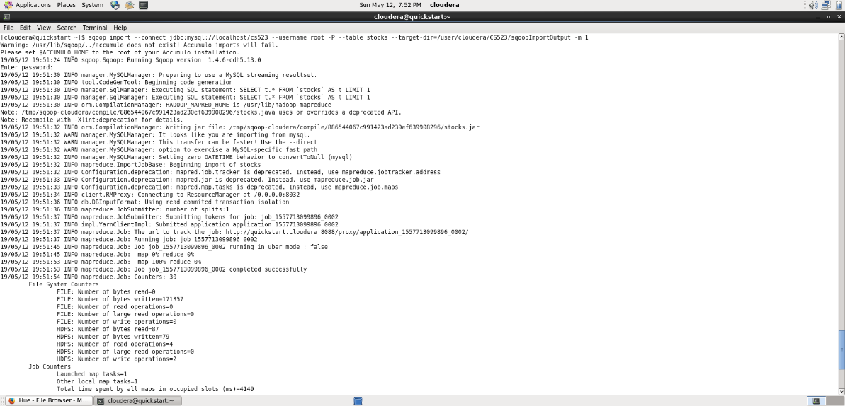

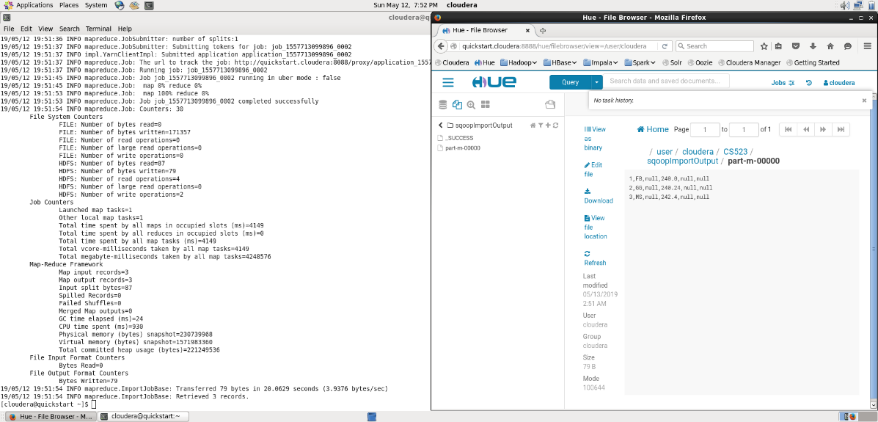

**Flume:**

// myFlumeConf.conf

agent1.sources = source1

agent1.sinks = sink1a sink1b

agent1.channels = channel1a channel1b

agent1.sources.source1.channels = channel1a channel1b

agent1.sinks.sink1a.channel = channel1a

agent1.sinks.sink1b.channel = channel1b

agent1.sources.source1.type = spooldir

agent1.sources.source1.spoolDir = /home/cloudera/Desktop/flume/spooldir

agent1.sinks.sink1a.type = hdfs

agent1.sinks.sink1a.hdfs.path = hdfs://localhost/user/cloudera/CS523/flumeImport/

agent1.sinks.sink1a.hdfs.filePrefix = events

agent1.sinks.sink1a.hdfs.fileSuffix = .log

agent1.sinks.sink1a.hdfs.fileType = DataStream

agent1.sinks.sink1b.type = logger

agent1.channels.channel1a.type = file

agent1.channels.channel1b.type = memory

//Exec code

flume-ng agent -n agent1 -c /home/cloudera/Desktop/flume/conf/ -f /home/cloudera/Desktop/flume/conf/myFlumeConf.conf

